
lAB 6 – Scale & Load Balance your Architecture
Timothy Victori

Timothy Victori
Engineering Department Arizona State University
IFT320: Managing the Cloud
Rahul Kashyap
April 21, 2025

LAB 6 – SCALE & LOAD BALANCE YOUR ARCHITECTURE
Figure 1
A screenshot of lab being submitted
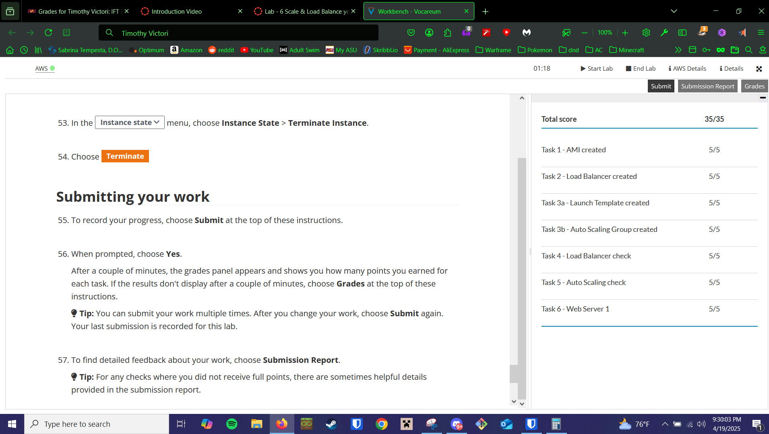 Q

